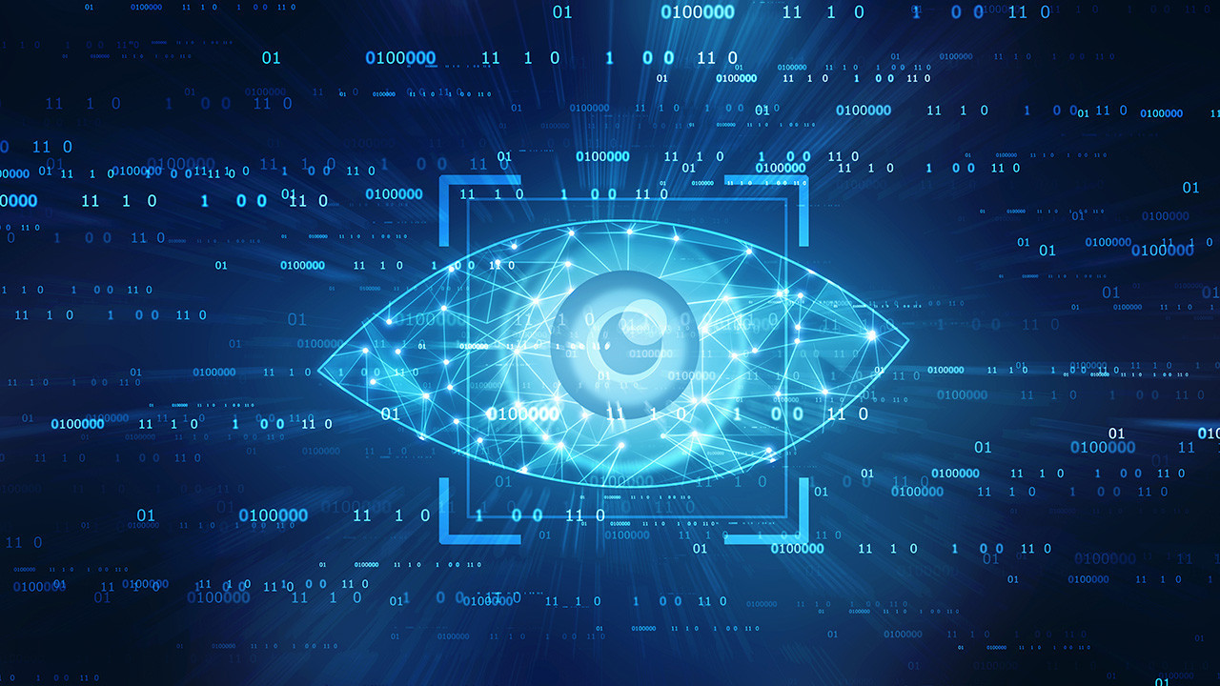

All tasks are completed by Ameya Harshad Chaudhari

Project 9: Image Classification using Deep Learning

* This project uses radiological imaging to determine whether the scanned patient has COVID-19 or not.
* Tools & libraries which I use: Spyder, Python3, Numpy, Tensorflow, Keras.
* Aim: With the Chest X - Ray dataset, develop a Deep Learning Model to classify the X Rays of Healthy vs Corona positive patients.